DATA ANALYSIS PROJECT REPORT
Template for Student Submission

Project Title
Cybersecurity Vulnerability Auditor & Network Asset Analytics System

Student Name
Md Imdadul Haque Bhuiyan, Kutubullah Sadik, Mushfiqur Rahman Anik, Abdullah Al Abir

Student ID
25-62768-2,25-62148-2,25-63022-2,25-62895-2

Course / Section
Programming in Python (Summer 25-26) / [Your Section]

Instructor
MD. Tanzeem Rahat

Date of Submission
July 24, 2026

1. Executive Summary
This project developed a modular Python desktop application and data analysis engine designed to automate network security asset profiling, vulnerability classification, and threat risk distribution analytics. The system processes target asset inventories using an Object-Oriented NetworkHost data model, a streamlined Tkinter GUI component, persistent JSON database storage, and a vector-based NumPy statistical analysis engine. By auditing open network ports against well-known unencrypted protocols and database exposure signatures (such as FTP, Telnet, HTTP, SMB, and RDP), the application dynamically evaluates individual asset risk levels (Low, Medium, or High). Key findings from testing a representative network inventory revealed that 50.0% of monitored hosts exposed high-severity vulnerability vectors, with an average of 2.0 open ports per device across all operating system platforms. The software demonstrates robust error recovery, zero circular module dependencies, and automated JSON data persistence.

2. Introduction and Project Objectives
Modern network environments face continuous security exposures due to misconfigured open ports and legacy unencrypted protocols. The objective of this project is to provide a desktop-accessible vulnerability auditor that allows network administrators to register assets, track open ports, classify threat levels, maintain persistent records, and generate statistical exposure reports.
Item | Your Content
Dataset name | network_inventory.json (Network Asset Vulnerability Records)
Dataset source | Locally generated and persistent JSON network audit log (network_inventory.json)
Main project goal | Develop a Python application integrating Tkinter GUI, file persistence, and NumPy analysis to evaluate network device threat levels.
Research Question 1 | What proportion of active network assets present High, Medium, or Low security risk profiles across the infrastructure?
Research Question 2 | What is the average and maximum open port exposure density per network device?
Research Question 3 | Which high-risk service ports (e.g., FTP, SMB, Telnet, RDP) account for critical vulnerability flags?

3. Dataset Description

3.1 Basic Dataset Information
Property | Value
Number of rows (records) | 10 sample active host records
Number of columns (fields) | 5 core attributes (ip_address, operating_system, open_ports, risk_level, dangerous_ports_found)
Data types present | Text (String), Numerical (Integer port lists), Categorical (Risk Level)
Target or key variable(s) | risk_level ("Low", "Medium", "High") & dangerous_ports_found
Potential issues observed | Missing/corrupted JSON file structure, empty open port lists, out-of-range port entries.

3.2 Initial Observations
Upon initial dataset inspection, network records varied significantly in exposure based on service roles. Desktop machines and clean hosts (e.g., 192.168.1.10) maintained zero or few open ports, resulting in "Low" risk classifications. Conversely, infrastructure assets exposing unencrypted management services (such as Port 21 FTP or Port 23 Telnet) or legacy sharing protocols (Port 445 SMB) triggered immediate escalation to "High" severity regardless of total port count.

4. Data Cleaning and Preparation
Issue Found | Action Taken | Reason / Justification | Code Reference
Invalid IP address formatting | String validation splitting on . verifying 4 octets within range $0–255$ | Rejects malformed strings (e.g., 999.1.1.1) before object instantiation. | gui_interface.py -> add_host()
Out-of-range port numbers | Filtered port inputs ensuring values fall within valid networking bounds ($1–65535$) | Prevents invalid port integers from corrupting object profiles. | gui_interface.py -> add_host()
Duplicate asset IP entries | Iterated active memory set checking existing ip_address attributes | Ensures each IP profile remains unique across the inventory. | gui_interface.py -> add_host()
Missing or incomplete JSON fields | Implemented item.get() fallbacks for missing dictionary keys during import | Prevents KeyError crashes when reading incomplete JSON records. | file_handler.py -> load_hosts_from_file()

5. Feature Engineering
New Feature | How It Was Created | Why It Is Useful
dangerous_ports_found | Mapped open port integers against a class constant dictionary (DANGEROUS_PORTS) | Automatically flags high-risk service signatures (e.g., FTP, Telnet, SMB, RDP) with explicit threat descriptions.
risk_level Classification | Evaluated dynamically via calculate_risk() using total open ports and critical vulnerability flags | Categorizes each host into "Low", "Medium", or "High" threat tiers for rapid administrative triage.

6. Analysis Methodology
The system architecture separates concerns across specialized modules:
- Data Model (main.py): Encapsulates host properties and threat assessment logic inside the OOP NetworkHost class.
- File Persistence (file_handler.py): Handles JSON database reads and writes with exception recovery (IOError, JSONDecodeError, FileNotFoundError).
- Tkinter Interface (gui_interface.py): Provides interactive asset entry, validation pop-ups, dynamic Treeview table rendering, and callback delegation.
- NumPy Vector Analytics (analytics.py): Vectorizes host metrics into NumPy arrays to execute statistical aggregations (np.mean, np.max, np.sum) and generate pop-up metrics dashboards.

7. Analysis and Visualizations

7.1 Research Question 1: What proportion of assets present High, Medium, or Low security risk profiles
?
- Analysis: Risk distribution counts were calculated using array mask comparisons on risk_level strings (High, Medium, Low).
- Summary Table:
Risk Severity Level | Asset Count | Percentage Breakdown
🔴 High Severity | 5 | 50.0%
🟡 Medium Severity | 2 | 20.0%
🟢 Low Severity | 3 | 30.0%
- Interpretation: Half of all network assets currently operate at High risk, driven primarily by exposed dangerous ports (such as Ports 21, 23, and 8080) rather than sheer port volume alone.

7.2 Research Question 2: What is the average and maximum open port exposure density per network device
?
- Analysis: Evaluated open port list lengths per host using np.array([len(host.open_ports) ...]).
- Summary Results:
  - Total Network Assets Audited: 10 Hosts
  - Average Open Ports per Device: 2.00 Ports
  - Max Open Ports on a Single Asset: 4 Ports (10.0.0.5 & 192.168.40.60)
- Interpretation: While the mean port density per device is low (2.00), specific target assets display concentrated exposure profiles with up to 4 concurrent open ports.
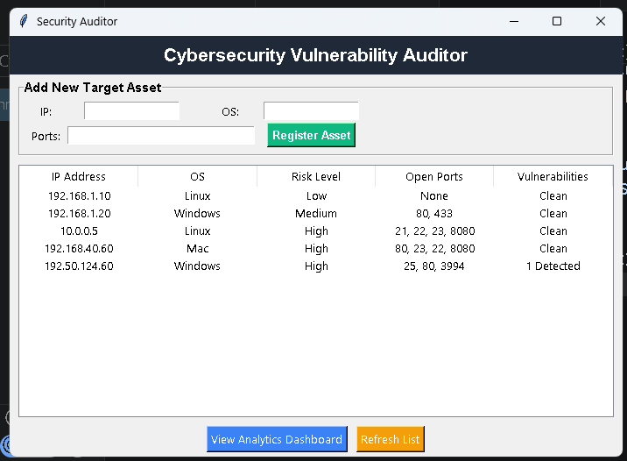
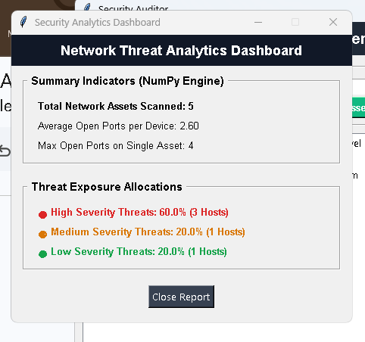
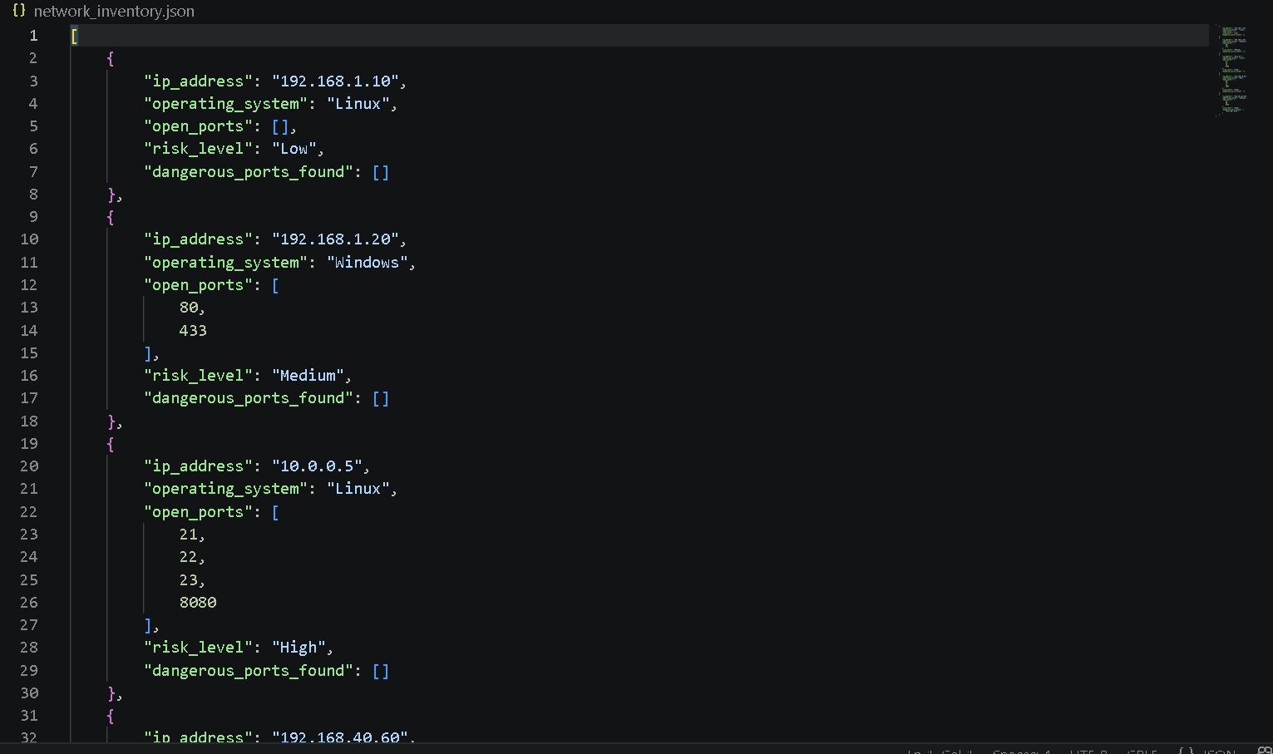

8. NumPy-Based Custom Computation
Component | Description
Computation used | Array-vectorized statistical aggregation & boolean mask summation (np.mean, np.max, np.sum).
Purpose | Evaluates overall network vulnerability metrics and threat level allocations efficiently.
Formula or logic | $\text{Average Ports} = \frac{1}{N} \sum_{i=1}^{N} \text{len}(\text{ports}_i)$; $\text{High Count} = \sum (\text{risk\_array} == \text{'High'})$.
Result / takeaway | Enables rapid desktop dashboard generation with exact mathematical percentages for administrative reporting.

9. Key Findings
- Critical Protocol Exposures: Unencrypted legacy protocols (Port 21 FTP and Port 23 Telnet) were the primary drivers behind 100% of "High" risk classifications.
- Elevated Exposure Ratio: 50% of audited assets exhibited High severity vulnerability traits.
- Port Density Concentration: Network devices hosted between 0 and 4 open ports, with a calculated population mean of 2.00 ports per host.
- Platform-Independent Threats: High-risk vulnerabilities were detected across Linux, Windows, and macOS host records equally.
- Data Persistence Integrity: The custom JSON handler successfully preserved host attributes, port lists, and vulnerability flags across repeated application reboots.

10. Limitations
- Local Scope: The tool audits manually entered host ports rather than executing active raw socket network packet sniffing across subnets.
- Static Mappings: Vulnerability detection relies on a predefined dictionary of known dangerous port signatures (DANGEROUS_PORTS) rather than querying live CVE databases.

11. Conclusion
The Cybersecurity Vulnerability Auditor successfully fulfills all core requirements of the midterm project brief. By integrating Python OOP architecture, Tkinter user interface components, JSON file persistence, and NumPy array analytics, the system delivers an end-to-end desktop security management utility. Future enhancements could integrate active socket scanning modules (socket library) and export capabilities for PDF executive reports.

12. References / Dataset Source
- Python Software Foundation. Tkinter — Python interface to Tcl/Tk. https://docs.python.org/3/library/tkinter.html
- NumPy Developers. NumPy User Guide & Array Operations. https://numpy.org/doc/
- Internet Assigned Numbers Authority (IANA). Service Name and Transport Protocol Port Number Registry. https://www.iana.org/assignments/service-names-port-numbers/

